“"The important thing is not to stop questioning. Curiosity has its own reason for existing."- Albert Einstein

Purpose
At Woodside C of E Primary School, we aim for all pupils to learn and achieve through our vision of ‘Together in God’s love we inspire and grow through living life in all its fullness.’ – John 10:10.

At Woodside, the Science curriculum inspires, challenges and encourages children; enabling them to become inquisitive, build their investigational skills and develop a deeper understanding of the wider world they live in.

The aims of the Science curriculum at Woodside are:

- To inspire, engage and challenge pupils in exploring the natural world through curiosity and investigation.
- To develop knowledge of a range of scientific concepts, including living things, materials, forces, and the Earth.
- To build understanding of how science relates to everyday life and encourage a lifelong interest in discovering how things work.
- To develop practical skills as young scientists, carrying out experiments safely and thinking critically about results.
- To appreciate the impact of science on our environment and promote sustainable and responsible choices for the future.

Our science curriculum makes full use of the rich environment around our school to bring learning to life. Pupils explore plant growth in our dedicated growing areas and polytunnel, observing life cycles and investigating what plants need to thrive. Natural spaces such as the pond and forest school provide opportunities to study animals, insects, and habitats in real contexts, supporting work on classification, adaptation, and food chains. These experiences promote sustainability and environmental responsibility, encouraging children to think about how to care for the world around them. By engaging with nature first-hand, we aim to create a sense of awe and wonder that inspires curiosity and a lifelong love of science.

Curriculum Organisation

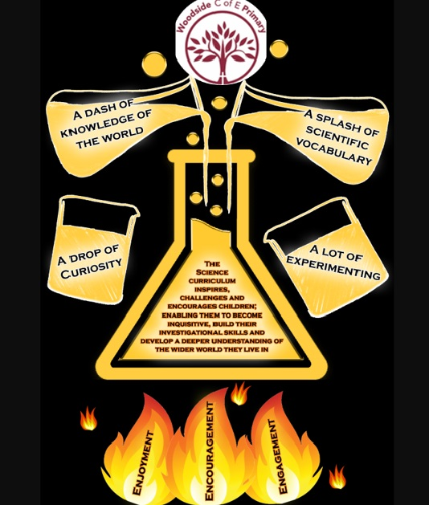
Our curriculum balances scientific knowledge with working scientifically, ensuring equal ambition for all pupils. Learning is designed around knowing more and remembering more over time, with strong links to the real world.

Children are encouraged to work scientifically in one of four ways:
- A dash of knowledge of the world- relating scientific concepts to real life happenings such as the effect gravity and air resistance has on a sky diver.
- A splash of scientific vocabulary- using scientific vocabulary in context such as using the words retina, iris, pupil, optic nerve and cornea when discussing how our eye works.
- A drop of curiosity- Asking thought provoking questions, rooted in scientific discovery to form the basis of enquiries and investigations.
- A lot of experimenting- Performing experiments to find out why and how things happen.

Every unit is driven by a thought-provoking scientific enquiry question, enabling children to explore key scientific concepts and fundamentals.

- What are the different parts of the body used for (Y1)
- What makes different materials good for different jobs? (Y2)
- What effect does magnetic force have of different objects? (Y3)
- How are electrical circuits made? (Y4)
- How do forces affect the movement of an object? (Y5)
- How does light behave? (Y6)
Each enquiry is supported by lesson-level key questions to guide assessment, deepen understanding and support children in forming evidence-based responses.

Early Years Foundation Stage (EYFS)
Science begins through exploration and observation, aligned with the EYFS framework’s “Understanding the World.” Children identify body parts, explore senses, and observe seasonal changes. They investigate simple concepts like light and dark, freezing and melting, and life cycles of plants and animals. This hands-on approach builds curiosity and foundational vocabulary, preparing pupils for more structured scientific enquiry in KS1.

Key Stage 1 (Years 1–2)
In KS1, pupils develop basic scientific knowledge and skills as outlined in the National Curriculum. Year 1 focuses on naming body parts, seasonal changes, and identifying animals and plants. Year 2 introduces materials and their properties, habitats, and what living things need to survive. Practical activities such as classifying and observing changes encourage pupils to ask questions and use simple tests, fostering early enquiry skills.

Lower Key Stage 2 (Years 3–4)
Progression moves towards greater complexity and abstract ideas. Year 3 introduces light, forces (magnets), and plant functions, while Year 4 explores sound, electricity, and states of matter. Pupils begin to use accurate measurements and systematic recording, developing an understanding of cause and effect. This stage reflects the National Curriculum aim for pupils to broaden their scientific view of the world and apply skills in varied contexts.

Upper Key Stage 2 (Years 5–6)
Science becomes more conceptually challenging and investigative. Year 5 covers life cycles, forces, Earth and space, and the circulatory system, linking biology and physics. Year 6 introduces evolution, classification, and advanced electricity and light concepts. Pupils apply prior knowledge to design fair tests, interpret data, and draw conclusions, preparing them for secondary science. This progression ensures pupils meet the National Curriculum goal of understanding key scientific ideas and working scientifically.

At Woodside, we don’t just teach science— we empower children to understand the importance of it, the way it gives meaning to everyday life and become adults who value the importance of it in our society.

Whole School Long-Term Plan – Science

