 |  | Autumn 1 |  | Autumn 2 |  | Spring 1 | Spring 2 |  |  | Summer 1 |  | Summer 2
Vision & Values | Value | Challening Injustice |  | Love |  | Hope | Forgiveness |  |  | Respect |  | Respect
Vision & Values | RE | 7-9 Sikhi E2  Do Sikhs think it is important to share? |  | UC2b.5 What would Jesus do? (Gospel) |  | UC 2b.1 What does it mean if God is holy and loving? (God)  Is anything ever eternal?  (10-11 C Spring 1) | UC 2b.8 What kind of king is Jesus? (Kingdom of God)  Is Christianity still a strong religion over 2000 years after Jesus was on Earth?  (10-11 C Spring 2) |  |  | 7-9 Sikhi E3  What is the best way for a Sikh to lead a good life? |  | 9-12 Sikhi E2  How are sacred teachings and stories interpreted by Sikhs today?
Vision & Values | PSHE  My Happy Mind | Meet your Brain  My Happy Mind Places |  | Shared Responsibilities  Showing Respect  Celebrate  Communities |  | Appreciate  First Aid  Drugs, Alcohol, Tobacco | Media Literacy and Digital Resilience  Relate  Safe Relationships |  |  | Engage  Be your best |  | Transition
English - Writing | Core Texts: | Traditional Tales  Myths & Legends of the World  Lonely Planet  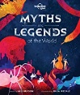 | NF: True Story  The Man who walked between the Towers  Mordicai Gerstein  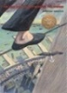 |  | Story: Historical Setting  Star of Hope, Star of Fear  Jo Hoestlandt  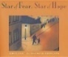 | Contemporary Fiction  Holes  Louis Sachar  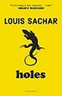 |  | Classic Poetry  Jabberwocky  Lewis Carroll  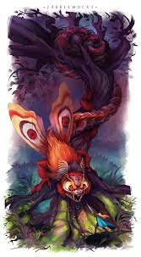 | Shakespeare  Macbeth  [extracts + version]  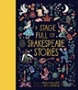 |  | Non-Fiction  Can we save the Tiger?Martin Jenkins  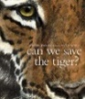
English - Writing | Final Writing Outcomes | Writing to narrate  Retell selected story in role as a character | Writing to describe  Setting Description |  | Writing to recount events  Diary in role as a character | Writing to narrate - dialogue  Dialogue between characters. |  | Writing to narrate  Opening section as a story  Writing to inform  Non-chronological report – Jabberwocky  Writing to narrate  Reverse narrative of the poem | Writing to describe Character description e.g. witches in role as a character  Writing to recount events  Diary in role as a character  Writing to recount events – journalistic  Newspaper article about the death of King Duncan |  | Writing to persuade  Persuasive letter about protecting / saving endangered species
English - Writing | Final Writing Outcomes |  | Writing to recount events – journalistic  Newspaper article about the events |  |  | Writing to persuade  Persuasive speech – ‘Come to Camp Green Lake’
English - Reading | Core Texts | Story: Historical Setting  When we Were Warriors  Emma Carroll | Poetry  Benjamin Zephaniah  * Talking Turkeys  * The British |  | Non-Fiction  Shackleton’s Journey  William Grill | Classic Fiction  The Happy Prince & Other Tales  Oscar Wilde |  | Non-Fiction  Great Adventurers  Alistair Humphries | Variety of Extracts |  | Contemporary Fiction  The Final Year  Matt Goodfellow

STEM | Maths | Number and Place Value  Addition and Subtraction  Multiplication and Division  Fractions  Geometry, position, and direction |  | Decimals  Percentages  Algebra  Measurement- converting units  Measurement: perimeter, area, volume and ratio |  | Geometry- properties of shape  Investigative problem solving  Statistics
STEM | Science | What causes components to function differently in a circuit? | How does light behave?  What factors affect the way people behave? | How do living things evolve over time?  How have you evolved over time? |  | How are all living things classified?  Are all living things creatures of God’s world?
STEM | Computing | Computing Systems and Networks –  Bletchley Park | Programming  Intro to Python | Data Handling  Big data 1 | History of computers  Creating media (audio) | Data Handing  Big data 2 | Skills showcase  Inventing a product
STEM | Computing | E Safety
Humanities | History | What significant turning points are remembered in Britain’s history?  Case Study: Winston Churchill  How did British history impact our future? |  | What is Benin’s significance to Britain?  Case Study: Eweka  Do the right people get to make money from the sale of chocolate? |  | How did the civil rights movement bring about change?  Case Study- Malcolm X  Is freedom important?
Humanities | Geography | What is the importance of African trade to different countries?  Case study- Chocolate  Do the right people get to make money from the sale of chocolate? |  | How are the physical features of the Polar regions different to the UK?  Case study- Tromso  What is the most surprising fact about life  in the Polar regions? |  | What is the impact of sustainability on the environment?  Case study- Peak District  Does it matter or not whether people care for the place they live?
 | PE | OAA  Tag Rugby  Gymnastics 1 |  | Dance  Hockey  Cricket |  | Rounders  Football  Athletics
The Arts | Art | Showcase: Portrait  Artist: Pablo Picasso  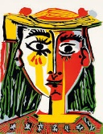  Media: Choice of media  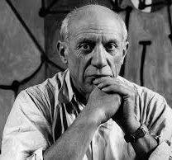 |  | Showcase: Abstract Shape  Artist: Barbara Hepworth  Media: Choice of media    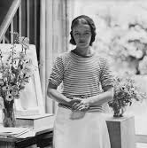 |  | Showcase: Street Art  Artist: Jean Michel Basquiat / Banksy  Media: Acrylics / Spray Paint  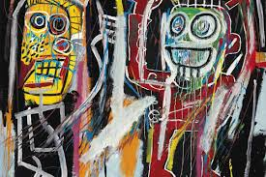  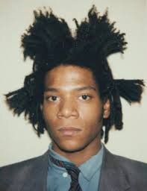  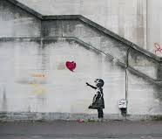
The Arts | DT |  | Discipline: Electrical Systems / Control  Product: Light-Up Sign  User: Visitors at St Nicholas’s Church  Purpose: To display at a Remembrance Exhibition  Designer: Luminati |  |   Discipline: Textiles  Product: Sustainable Fashion piece  User: Child in Year 6  Purpose: To win the Woodside Sewing Bee competition  Designer: Stella McCartney |  | Discipline: Cooking & Nutrition  Product: Afternoon Tea  User: Year 6 parents / families  Purpose: To eat at a Y6 leavers’ event  Designer: Ravneet Gill
The Arts | Music | Disco fever  Wake up |  | Djembe drums |  | Heal the Earth  Let’s go surfing
French |  | At The Tearoom – giving opinions  The Date |  | At School – telling the time  Clothes – What do you like to wear? |  | The weekend
Wider curriculum | Trips and workshops | - European languages day  - Composting Warwickshire Collective Worship  - NSPCC Workshop  - Loudmouth Workshop |  | - Plastic Free Warwickshire Collective Worship |  | - Trip to Birmingham (Leaver’s Service)  - Food Waste Warwickshire Collective Worship
Wider curriculum | Christian Ethos | - Messy Harvest  - Messy Christmas |  | - Messy Easter |  | - Pentecost

