 |  | Autumn 1 |  | Autumn 2 |  | Spring 1 |  | Spring 2 |  |  | Summer 1 |  | Summer 2
Vision & Values | Value | Challenging Injustice |  | Love |  | Hope |  | Forgiveness |  |  | Respect |  | Respect
Vision & Values | RE | 9-12 Islam E2  How is the Qur’an vital to Muslims today? |  | UC 2b.4 Was Jesus the Messiah? (Incarnation)  How significant is it for Christians to believe that God intended Jesus to die?  (9-10 C Spring 2) |  | 9-12 Islam E3  Does belief in Akhirah (life after death) help Muslims lead a good life? |  | UC 2b.6 What did Jesus do to save human beings? (Salvation)  How significant is it for Christians to believe that God intended Jesus to die?  (9-10 C Spring 2) |  |  | UC 2b.2 Creation and Science: conflicting or complementary? (Creation)  What motivates Humanists to lead good lives?  (7-9 H Enquiry 1) |  | 9-12 Humanism E1  How do inspirational people impact on how Humanists live today?
Vision & Values | PSHE  My Happy Mind | Meet your brain  My Happy Places |  | Celebrate |  | Appreciate  Healthy Lifestyles |  | Relate  Friendships  Families and Close Relationships |  |  | Engage  Economic Wellbeing |  | Growing and Changing (Grief)  Growing and Chaning Transition
English - Writing | Core Texts: | Traditional Tales  Just so Stories  Rudyard Kipling  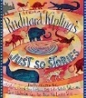 | Fiction  Tuesday  David Wiesner |  | Non-Fiction  A Year Full of Celebrations and Festivals  Christopher Corr | Story: Historical Setting  Cinderella of the Nile  Beverley Naidoo | Contemporary Fiction  The Paperbag Prince  Colin Thompson |  | Non-Fiction  The Happy News | Shakespeare  A Midsummer Night’s Dream  [extracts & version]  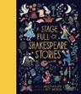 |  | NF: True Story  Queen of the Falls  Chris van Allsburg  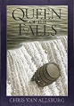 |  | Contemporary Fiction  Floodland  Marcus Sedgwick  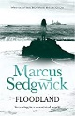
English - Writing | Final Writing Outcomes | Writing to narrate  Alternative opening or ending to one of the stories | Writing to describe  Setting Description |  | Writing to inform  Non-chronological report – festivals | Writing to describe  Character Description – Rhodopis | Writing to persuade  Persuasive letter about ‘reduce, reuse, recycle’ |  | Writing to recount events – journalistic *  Newspaper article about a current event | Writing to narrate - dialogue  Dialogue between characters |  | Writing to recount events – journalistic *  Newspaper article about the events |  | Writing to narrate -  New chapter
English - Writing | Final Writing Outcomes |  | Writing to recount events  Diary in role as a character |  |  | Writing to narrate  Retell story in role as Rhodopis |  |  |  |  |  |  |  | Writing to persuade  Persuasive speech in role as Dooby – ‘join the gang’
English - Reading | Core Texts: | Traditional Tales  African Tales – A Barefoot Collection  Gcina Mhlophe & Rachel Griffin | Poetry  Moon Juice  Kate Wakeling  * Comet  * The Instructions |  | Classic Fiction  Harry Potter & the Philosopher’s Stone  JK Rowling | Contemporary Fiction  The Last Wild  Piers Torday |  | Non-Fiction  What a Waste  Jess French |  | Story: Historical Setting  The Clockwork Crow  Catherine Fisher |  |  | Non-Fiction  The Cities Book  Lonely Planet Kids

STEM | Maths | Number and Place Value  Addition and Subtraction  Multiplication and Division  Measurements: area and perimeter  Statistics |  | Multiplication and division  Fractions  Decimals and percentages |  | Decimals  Geometry- properties of shapes  Position and direction  Measurements: converting units  Measures- volume
STEM | Science | What are the similarities and differences between the life cycles of living things?  What connects you and other living things? | How do forces affect the movement of an object?  Can you feel a force /connection between you and your friend? | How does the Earth move in the solar system?  How do you feel when you see a picture of the earth from space? | How do materials react differently when mixed together?  Do the right people get to make money from the sale of chocolate? | What are the circulatory and respiratory systems?
STEM | Computing | Computing Systems and Networks –  Search engines | Programming  Music | Data Handling  Mars Rover | Programming  Micro: bit | Creating media  Stop motion | Skills showcase  Mars Rover 2
STEM | Computing | E Safety
Humanities | History | How did Britain change between 1400 and 1600?  Case Study: Battle of Bosworth  Do you think Henry VIII ever found true love? |  | Why was Queen Elizabeth I’s reign so significant for England?  Case Study: Spanish Armada  What would it feel like to be a first civilian? |  | Ancient Civilisations: What significance do they have today?  Case Study: Cleopatra  How are you cautious?
Humanities | Geography | How do the physical features of mountains impact on locality?  Case study: Alps  Why do people want to climb mountains? How does it feel to think about the size of a mountain? |  |  |  | Why is the Amazon rainforest important?  Case study: Amazon  What amazes you about the rainforest?
 | PE | Sports leadership  Tag Rugby  Gymnastics 1 |  | Gymnastics 2  Hockey  Cricket  Dance |  | Rounders  Football  Athletics  OAA
The Arts | Art | Showcase: Still Life  Artist: Frida Kahlo  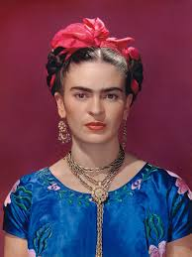  Media: Pastels  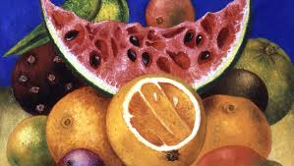 |  | Showcase: Moving Figure  Artist: Augusta Savage  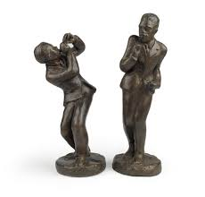  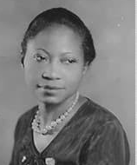  Media: Clay |  | Showcase: Seasonal Painting  Artist: David Hockney  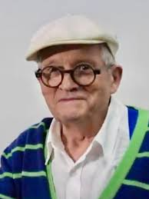  Media: Acrylics  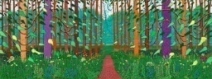
The Arts | DT |  | Discipline: Cooking & Nutrition  Product: Street Food (pasty / samosa)  User: Parents / families at Woodside  Purpose: To eat at a Pop-Up Street Food event  Chef: Omari McQueen |  | Discipline: Structures  Product: Bird Hide  User: Local birds  Purpose: To provide shelter in school grounds  Designer: Douglas Barnhard |  | Discipline: Mechanisms  Product: Racing Car (Axles & Wheels)  User: Children in Year 5  Purpose: To win the Woodside F1 Race  Designer: Adrian Newey  
The Arts | Music | Ghost parade  You are the sparkle in my life |  | Djembe drums |  | Eerie canal  Look into the night
 | French | Ice Creams - What would you like?  At The Tearoom – ordering food |  | Do You Have A Pet?  Animals – what colours are they? |  | Clothes –What do you have?  At School – Which subjects do you like?
Wider curriculum | Trips and workshops | - European languages day  - Composting Warwickshire Collective Worship |  | Plastic Warwickshire Collective Worship |  | - Trip to?  - Food Waste Warwickshire Collective Worship
Wider curriculum | Christian Ethos | - Messy Harvest  - Messy Christmas |  | - Messy Easter |  | - Pentecost

