 |  | Autumn 1 |  | Autumn 2 |  | Spring 1 |  | Spring 2 |  |  | Summer 1 |  | Summer 2
Vision & Values | Value | Challenging Injustice |  | Love |  | Hope |  | Forgiveness |  |  | Respect |  | Respect
Vision & Values | RE | 7-9 Sikhi E2  Do Skihs think it is important to share? |  | UC 2a.3: What is the Trinity? (Incarnation)  Does belief in the Trinity help Christians make better sense of God as a whole? |  | 9-12 Sanatana Dharma E2  How can Brahman be everywhere and in everything? |  | UC 2a.4 What kind of world did Jesus want? (Gospel)  Is forgiveness always possible for Christians?  (8-9 C Spring 2) |  |  | UC2a.6 When Jesus left, what was the impact of the Pentecost?  For Christians, what was the impact of the Pentecost?  (10-12 C Spring 2 Alt) |  | 7-9 Humanism E1  What motivates Humanists to lead good lives?
Vision & Values | PSHE  My Happy Mind | My Happy Mind - Meet your brain, places and celebrate |  | My Happy Mind - Meet your brain, places and celebrate |  | My Happy Mind – Appreciate  First aid  Media literacy and digital resilience |  | My Happy Mind – Relate  Safe relationships |  |  | My Happy Mind – Engage  Keeping safe |  | Economic wellbeing  Ourselves, growing and changing
English - Writing | Core Texts: | Contemporary Fiction  Leon & the Place Between  G Baker-Smith  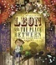 | Classic Fiction  The Lion, the Witch & the Wardrobe [abridged]  CS Lewis  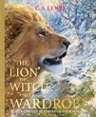 |  | Non-Fiction  The Romans – Britain in the Past  Moira Butterfield  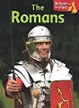 | Story: Historical Setting  Escape from Pompeii  Christina Balit  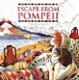 | NF: True Story  One Plastic Bag  Miranda Paul  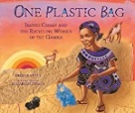 |  | Contemporary Fiction  The Tin Forest  Helen Ward  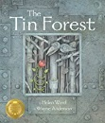 | Traditional Tales  The Adventures of Robin Hood  Maricia Williams  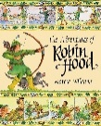 |  | Contemporary Fiction  Peace Maker  Malorie Blackman  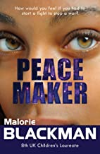 |  | Non-Fiction  Fantastically Great Women…  Kate Pankhurst  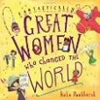
English - Writing | Final Writing Outcomes | Writing to recount events  Diary from Leon’s point of view from the place between | Writing to narrate  Dialogue between two characters |  | Writing to inform  Non-chronological report e.g Roman Army | Writing to describe  Setting Description | Writing to persuade  Persuasive speech to villagers |  | Writing to recount events  Diary in role as a character | Writing to describe  Character description – Robin Hood |  | Writing to persuade  Persuasive letter about wearing the Peace Maker in role as the commander |  | Writing to inform describe  Non-chronological report about ‘great women’
English - Writing | Final Writing Outcomes |  | Writing to describe  Character description – key character e.g. Aslan |  |  | Writing to narrate  Re-tell the story from a character’s point of view |  |  |  |  |  | Writing to narrate  Next chapter

English - Reading | Core Texts: | Traditional Tales  A World full of Animal Stories  Angela McAllister | Poetry  Roger McGough  * The Lost Lost Property Office  * Alternative Santa | Contemporary Fiction  Robot Girl  Malorie Blackman | Non-Fiction  Volcanoes DK Find Out | Traditional Tales  Atlantis  Christina Balit | Contemporary Fiction  Ariki and the Island of Wonders  Nicola Davies | Non-Fiction  Animals on the Edge: Gorilla  Anna Claybourne | Classic Fiction  The Firework Maker’s Daughter  Philip Pullman

STEM | Maths | Number and Place Value  Addition and Subtraction  Multiplication and Division  Measurement- length and perimeter |  | Multiplication and division  Measurement- area  Fractions  Decimals |  | Decimals  Measurement – money  Time  Geometry- properties of shape, position and direction
STEM | Science | How are plants and animals classified?  Why is it important to look after God’s creatures? | How are different sounds made?  Which sounds make people feel safe or uncomfortable? | What is the digestive system and how does it work?  Is what you put inside your body important? | How are electrical circuits made?  Is a relationship is like a circuit? | How are solids, liquids and gases similar and different?  How does a liquid make you feel when you look at it?
STEM | Computing | Microsoft: Computing Systems and Networks –  Collaborative learning | Programming  Further coding with Scratch | Microsoft: Creating media  Website design | Skills showcase  HTML | Programming 2  Computational thinking | Data handling  Investigating weather
STEM | Computing | E Safety
Humanities | History | Why was Romanisation significant to Britain?  Case Study: Boudicca  Can I see the affects of the Roman Empire still today? |  | What changes did the Saxons make in Britain?  Case Study: Alfred the Great  What do I admire about the Anglo Saxons? |  | Why was 1066 a significant year for Britain?  Case Study: William Duke of Normandy  Do good leaders have to be nasty to get a job done?
Humanities | Geography | How do the physical features of rivers impact on locations and people?  Case study: Nile and Amazon  Why should people look after rivers? |  |  |  | What are the similarities and differences between North and South America?  Case study: New Orleans and Rio De Janeiro What do you have in common with people in New Orleans and Rio De Janeiro?
 | PE | Dance  Basketball  Gymnastics 1  Handball |  | Football  Cricket  Gymnastics 2 |  | Swimming  Rounders  Athletics
The Arts | Art | Showcase: Buildings  Artist: Antoni Gaudi  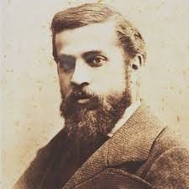  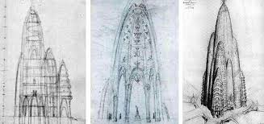  Media: Pencil & Charcoal |  | Showcase: Sea Creature  Artist: Michelle Reader  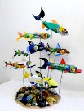  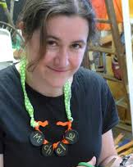  Media: Recycled materials |  | Showcase: Pop Art Portrait  Artist: Andy Warhol  Media: Poster Paint  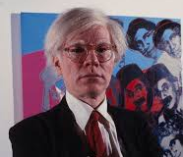  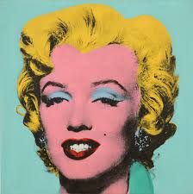
The Arts | DT |  | Discipline: Textiles Product: Pencil Case  User: Me  Purpose: To store school equipment  Designer: Stephen Meurs (Smiggle)   |  | Discipline: Cooking & Nutrition  Product: Stir Fry  User: Children at Woodside  Purpose: To add diversity to Chartwell’s school menu  Chef: Nadiya Hussein |  | Discipline: Electrical Systems  Product: Nightlight  User: Children in Year 4  Purpose: To use on a school residential visit  Designer: B&Q design team
The Arts | Music | Looking in the mirror  Bringing us together |  | Ukulele |  | Train is a coming  You can see it through
 | French | Presenting Myself  My Family |  | Vegetables  Fruits – What would you like? |  | In The Classroom  My Home
Wider curriculum | Trips and workshops | - European languages day  - Composting Warwickshire Collective Worship |  | - Plastic Free Warwickshire Collective Worship  Residential |  | - Trip to Thinktank Museum  - Food Waste Collective Worship
Wider curriculum | Christian Ethos | - Messy Harvest  - Messy Christmas |  | - Messy Easter |  | - Pentecost

