 |  | Autumn 1 |  | Autumn 2 |  | Spring 1 |  | Spring 2 |  |  | Summer 1 |  | Summer 2
Vision & Values | Value | Challenging Injustice |  | Love |  | Hope |  | Forgivness |  |  | Respect |  | Respect
Vision & Values | RE | 7-9 Islam E2  Does completing a pilgrimage make someone a better Muslim? |  | UC2a.1 What do Christians learn from the Creation story?  What do Christians believe about God?  (5-6 C Autumn 1) |  | UC2a.2 What is it like to follow God?  Is anything ever eternal?  (10-11 C Spring 1) |  | UC 2a.5 Why do Christians call the day Jesus died ‘Good Friday’?  What is ‘good’ about Good Friday?  (7-8 C Spring 2) |  |  | 7-9 Islam E3  What is the best way for a Muslim to lead a good life? |  | 5-7 Humanism E1  What do Humanists believe?
Vision & Values | PSHE  My Happy Mind | Meet your brain  My Happy Places |  | Celebrate |  | Appreciate  Healthy Lifestyles |  | Relate  Friendships  Families and positive relationships |  |  | Engage  Communities  Shared Responsibilities |  | Growing and Changing (Grief)  Transition
English - Writing | Core Texts: | Story: Historical Setting  Stone Age Boy  Satoshi Kitamura  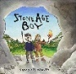 | Non-Fiction  Explore! Stone, Bronze & Iron Ages  Sonya Newland  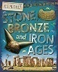 |  | Contemporary Fiction  Seal Surfer  Michael Foreman  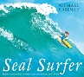 | Traditional Tales  The Orchard book of 1st Greek Myths  Saviour Pirotta  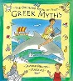 | Contemporary Fiction  Winter’s Child  Angela McAllister  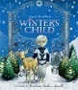 |  | NF: True Story  Zeraffa Giraffa  Dianne Hofmeyr  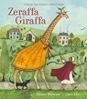 | Non-Fiction  Illustrated Atlas of Britain & Ireland  Usborne  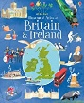 |  | Classic Fiction  The Hodgeheg  Dick King Smith  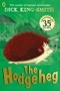 |  | Contemporary Fiction  Mouse, Bird, Snake, Wolf  David Almond
English - Writing | Final Writing Outcomes | Writing to narrate  Retelling the story Stone Age Boy | Writing to inform  Non-chronological report – daily life in Stone Age |  | Writing to describe  Setting description | Writing to describe  Character Description – Minotaur | Writing to instruct  Instructions linked to growing seeds / plants |  | Writing to recount events  Diary from the girl’s point of view | Writing to inform  Non-chronological report – local area |  | Writing to describe  Character Description – Max |  | Writing to narrate  New ending for the story inc. short dialogue
English - Writing | Final Writing Outcomes |  |  |  | Writing to recount events  Diary in role recounting events – boy to friend/Grandad | Writing to narrate  Retell myth in own words e.g. Theseus & the Minotaur |  |  |  |  |  | Writing to instruct  Instructions for Road Safety

English - Reading | Core Texts: | Non-Fiction  The Sea Book  Charlotte Milner | Poetry  Please Mrs Butler  Alan Ahlberg  * Scissors  * Dog in the Playground | Classic Fiction  Ice Palace  Robert Swindells | Traditional Tales  The Egyptian Cinderella  Shirley Climo | Contemporary Fiction  This Morning I Met a Whale  Michael Morpurgo | Non-Fiction  Mad About Cartoons  Judith Heneghan | Classic Fiction  The Iron Man  Ted Hughes

STEM | Maths | Number and Place Value  Addition and Subtraction  Multiplication and Division |  | Measurement- money  Multiplication and division  Statistics  Measurement- Length and height |  | Fractions  Measurement- Time  Geometry- properties of shape  Measurement- Mass and Capacity
STEM | Science | How are we able to move?  Does how you move impact your health? | Where does light come from?  Why is light an important symbol? How does it make people feel? | How are rocks and soils similar and different?  What do you admire about rocks? | What affect does magnetic force have on different objects?  What else connects like a magnet? | How do the different parts of a plant affect how well it grows?  How does it feel to watch a plant grow?
STEM | Computing | Computing Systems and Networks – | Programming  Scratch | Computing systems and networks-  Emailing | Computing systems and networks-  Journey inside a computer | Creating media- Video trailers | Data handling-Comparison cards- databases
STEM | Computing | E Safety
Humanities | History | How did Britain change over the Stone, Bronze and Iron Age?  Case Study: Skara Brae  How similar would the Stone Age be to living in Baddesley today? |  | Why were the Greeks significant to the western world?  Case Study: Alexander the Great  What connects me to Ancient Greece? |  | Why was Alan Turing significant in World War II?  Case Study: Alan Turing  What do you think you have to do to have a significant impact on others’?
Humanities | Geography | How do different natural disasters impact on locations and people?  Case study: European country (Italy) and Pompeii.  What can people do when they see others impacted by natural disasters? |  |  |  | What are the human and physical features of Warwickshire?  Case study: Warwickshire  What are our favourite physical features in Warwickshire? How can we show that they matter to us?
 | PE | Gymnastics 1  Dance 1  Netball  Basketball |  | Football  Cricket  Gymnastics 2  Dance 2 |  | Rounders  Athletics  swimming
The Arts | Art | Showcase: In the Forest  Artist: Yayoi Kusama  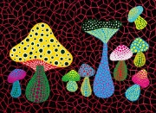  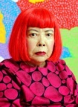  Media: Coloured Pencils |  | Showcase: Abstract Shape  Artist: Anish Kapoor  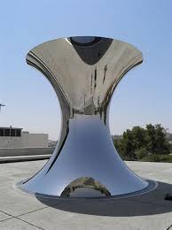  Media: Clay  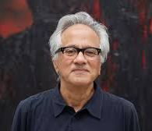 |  | Showcase: River Scene  Artist: Claude Monet  Media: Watercolour  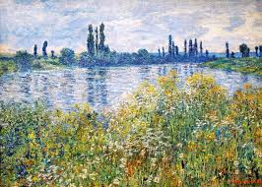  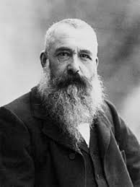
The Arts | DT |  | 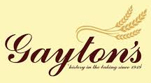  Discipline: Cooking & Nutrition  Product: Scone  User: Gayton’s  Purpose: To add to the range of scones sold at Gayton’s  Baker: David Gayton |  | Discipline: Structures  Product: Mini Greenhouse  User: Children at Woodside  Purpose: To grow plants in  Architect: Sir Nicholas Grimshaw |  | Discipline: Mechanisms  Product: Mascot (Pneumatics)  User: Baddersley Ensor Kick About  Purpose: To promote the team in the local area  Designer: Crispin Lowry (Rainbow Productions)
The Arts | Music | Let your spirit fly  Three little birds |  | Ukuleles |  | When the saints  Why does music make a difference?
 | French | I Am Learning French  Animals |  | Instruments  Sports |  | Fruits – What do you like?  Ice Creams - What do you like?
Wider curriculum | Trips and workshops | - European Languages Day  - Composting Warwickshire Collective Worship |  | - Plastic Free Warwickshire Collective Worship |  | - Trip to?  - Food Waste Warwickshire Collective Worship
Wider curriculum | Christian Ethos | - Messy Harvest  - Messy Christmas |  | - Messy Easter |  | - Pentecost

