 |  | Autumn 1 | Autumn 2 | Spring 1 | Spring 2 | Summer 1 | Summer 2
Vision & Values | Value | Challenging Injustice | Love | Hope | Forgivness | Respect | Respect
Vision & Values | RE | UC 1.4: What is the good news that Jesus brings? (Gospel)  Is it possible to be kind to everyone all of the time?  (6-7 C Autumn 1) | UC 1.3 Why does Christmas matter to Christians? (Incarnation)  What gifts might Christians in my town have given Jesus if he had been born here rather than in Bethlehem? | 5-7 Sikhi E1  Who is God to Sikhs? | UC 1.5: Why does Easter matter to Christians? (Salvation)  Why was Jesus welcomed like a king or celebrity by the crowds on Palm Sunday? | 5-7 Sikhi E2  Why do Sikhs admire their Gurus? | 5-7 Sikhi E3  Does taking part in Baisakhi help Sikh children feel a sense of belonging?
Vision & Values | PSHE  My Happy Mind | Meet your brain  Places | Celebrate | Appreciate  Keeping Safe | Relate  Friendships | Engage  Safe Relationships  Economic | Economic Wellbeing  Transition

English - Writing | Core Texts: | Traditional Tales  The Elves and Shoemaker  Ladybird  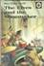 | Non-Fiction  Castles Maggie Freeman  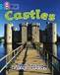 | Contemporary Fiction  The Dragon Machine  Helen Ward  [Pathways 3]  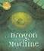 | Classic Fiction Where the Wild Things are  Maurice Sendak  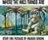 | Contemporary Fiction  Lila and the Secret of Rain  David Conway  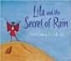 | Non-Fiction  Cooking Step by Step  DK  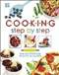 | Classic Fiction  The Owl who was Afraid of the Dark  Jill Tomlinson  [Pathways 2]  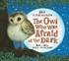 | Contemporary Fiction  The Koala who Could  Rachel Bright  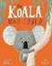 | Traditional Tales  Rapunzel  Beth Woollvin  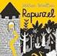 | Non-Fiction  Above and Below  Hanoko Clulow  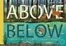
English - Writing | Final Writing Outcomes | Writing to narrate  Retell the story in own words | Writing to inform  Non-chronological report – castles | Writing to recount events  Recount in role as George | Writing to describe  Setting description | Writing to narrate  Retell the story in own words | Writing to instruct  Instructions for a recipe e.g. pancakes | Writing to describe  Character description – Plop | Writing to describe  Character description – Kevin | Writing to instruct  Instructions for climbing down the tower | Writing to inform  Non-chronological report – topic-linked e.g. coasts
English - Writing | Final Writing Outcomes |  |  |  |  |  |  | Writing to recount events  Diary in role as Plop |  | Writing to narrate  Ending to the story

English - Reading | Core Texts: |  |  | Big Cat Text  Tiger’s Tale  Michaela Morgan   | Big Cat Text  The Camel Fair  Wendy Cooling  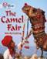 | Big Cat Text  The Great Pebble Puzzle  Ali Sparkes  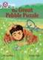 | Classic Fiction  Fantastic Mr Fox  Roald Dahl  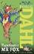

STEM | Maths | Number and Place Value  Addition and Subtraction  Measurement- Money  Multiplication and division |  | Multiplication and division  Statistics  Geometry  Properties of shape  Fractions  Measurements- height and length |  | Position and direction  Problem solving and efficient methods  Measurement- time, mass, capacity, and temperature
STEM | Science | What makes different materials good for different jobs?  What qualities do you have that make you good at certain jobs? | What are the characteristics of living things? | How are habitats similar and different?  Which habitat seems most appealing to you? | What do animals and humans need to survive and stay healthy?  Do you need the same as an animal to survive? | What do plants need to grow?  What do I need to grow? Is it more than a plant needs?
STEM | Computing | Computing systems and networks- What is a computer? | Programming-  Algorithms and de bugging | Computing systems and networks-  Word processing | Programming – Scratch Jnr | Creating Media-  Stop Motion | Data Handling- International Space Station
STEM | Computing | E Safety
Humanities | History | How have castles changed over time?  Case Study: Tamworth Castle  How doers my local castle compare? |  | Why is Walter Tull significant?  Case Study: Walter Tull  What was Walter Tull’s protected characteristic? Did this make him any different? |  | Why is Grace O’Malley important for Irish history?  Case Study: Grace O’ Malley  What qualities did Grace have? Which of these qualities do I share?
Humanities | Geography | What are the physical and human features of the world?  Case study: Africa  .  What is the most amazing thing to see in Africa? |  | How is Malawi similar and different to the UK?  Case study: Malawi  What seems good about living in the Lake District? What seems good about living in Malawi? |  | How are locations by the coast similar and different?  Case study: Blackpool and Rio De Janeiro  What amazes you most about the sea?
 | PE | Gymnastics 1  Attack, defend, shoot 1  Dance 1  Attack, defend, shoot 2 |  | Gymnastics 2  Hit, catch, run 1.  Dance 2  Hit, run, catch 2 |  | Run, jump, throw 1.  Send and return 1.  Run, jump, throw 2.  Send and return 2
The Arts | Art | Showcase: Street Scene  Artist: James Rizzi  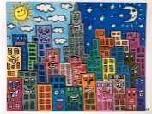  Media: Wax Crayons  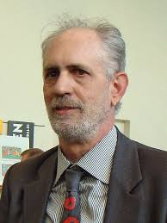 |  | Showcase: Lines & Shapes  Artist: Cassie Stephens  Media: Paper & Cardboard  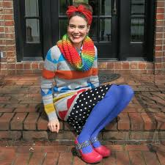  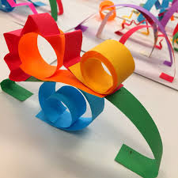 |  | Showcase: School Playground  Artist: LS Lowry  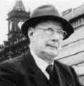  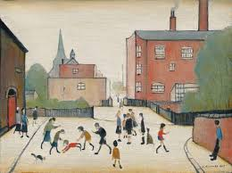  Media: Watercolour
The Arts | DT |  | Discipline: Textiles  Product: Puppet  User: Me  Purpose: To use in a puppet show  Designer: Chris Barlow |  |   Discipline: Cooking & Nutrition  Product: Pizza  User: Children eating at Pizza Express  Purpose: To add a new pizza to the Piccolo menu  Designer: Peter Boizot (Pizza Express) |  | Discipline: Structures  Product: Model Village  User: Visitors at St Nicholas’s Church  Purpose: To display at a Church exhibition  Architect: Tim Dunn
The Arts | Music | Hands, feet, heart  I wanna play in a band |  | Zoo time  Orchestra song |  | The music man  The sunshine song
Wider curriculum | Trips and workshops | - European languages day  - Composting Warwickshire Collective Worship |  | - Plastic Free Warwickshire Collective Worship |  | - Trip to?  - Plastic Free Warwickshire Collective Worship  - Food Waste Warwickshire Collective Worship
Wider curriculum | Christian Ethos | - Messy Harvest  - Messy Christmas |  | - Messy Easter |  | - Pentecost

