 |  | Autumn 1 | Autumn 2 | Spring 1 | Spring 2 | Summer 1 | Summer 2
Vision & Values | Value | Challenging Injustice | Love | Hope | Forgivness | Respect | Respect
Vision & Values | RE | UC 1.1 What do Christians believe about God? (God) 5-6 Christianity A1  What do Christians believe about God? | UC1.2: Who made the world? (Creation)  Who made the world? | 5-7 Islam E1  Who is God to Muslims? | UC 1.5 (double salvation) 6 Christianity Sp2  Why was Jesus welcomed like a king or celebrity by the crowds on Palm Sunday? | 5-7 Islam E2  How important is the Prophet Muhammad to Muslims? | 5-7 Islam E3  How important is the Qur’an to Muslims?
Vision & Values | PSHE  My Happy Mind | Meet your brain  My Happy Mind Places | Showing Respect  Celebrate | Appreciate  Healthy Lifestyles | Relate  Families and close relationships | Engage  Shared Responsibilities | Communities  Growing and Changing  Transition

English – Writing | Core Texts: | Traditional Tales  The Three Billy Goats Gruff  Ladybird  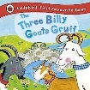 | Classic Fiction  Dogger  Shirley Hughes  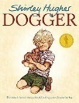 | Contemp Fiction  Room on the Broom  Julia Donaldson  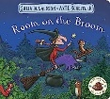 | Contemp Fiction  Lost and Found  Oliver Jeffers  [Pathways 1]  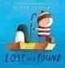 | Contemp Fiction  The Lion Inside  Rachel Bright  [Pathways 3]  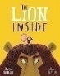 | Traditional Tales  The Gingerbread Man  Ladybird  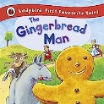 | Classic Fiction  Katie in London  James Mayhew   | Non-Fiction  The Big Book of Beasts Yuval Zommer  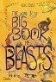 | Contemp Fiction  Grandma Bird  Benji Davies  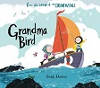 | Classic Fiction  The Tiger who came to tea  Judith Kerr   | Non-Fiction  Fact Cat: Weather  Izzi Howell  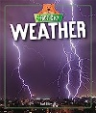 | Traditional Tales  The Hare and the Tortoise  Brian Wildsmith  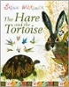
English – Writing | Writing Outcomes | Writing to narrate  Sentence in role as the Troll e.g. in speech bubble | Writing to recount events  Sentence(s) about the Summer Fayre in role as Dave/Bella | Writing to describe  Sentence(s) about what the witch can see (setting) | Writing to narrate  Sentence(s) in role as a character e.g. in speech bubble | Writing to describe  Sentence(s) about the lion | Writing to narrate  Sentences to retell the story in own words | Writing to describe  Sentence(s) about the setting (London) | Writing to inform  Information text about an animal | Writing to describe  Setting description – inside & outside Grandma’s house | Writing to recount events  In role as the girl | Writing to inform  Information text about weather | Writing to describe  Description of the hare
English – Writing | Writing Outcomes | Writing to describe  Sentence(s) about the troll | Writing to describe  Sentence(s) about Dogger e.g. for ‘Lost’ poster | Writing to recount events  Sentence(s) in role as a character | Writing to describe  Sentence(s) about a place in the story (setting) | Writing to narrate  Sentences in role as the mouse & the lion e.g. in thought bubbles | Writing to recount events  Sentences in role as the fox e.g. for letter to friend | Writing to narrate  Own Katie story e.g. Katie in Baddesley |  |  | Writing to narrate  Own ‘X came to tea’ story |  | Writing to narrate  Retell the story in own words
English – Writing |  | Writing to narrate  Sentence(s) about the story | Writing to narrate  Sentence(s) retelling the story | Writing to instruct  Simple command sentences for potion | Writing to inform  Sentence{s) about penguins |  | Writing to instruct  Simple instructions e.g. gingerbread man

STEM | Maths | Mastering Number  Measurement |  | Mastering Number  Multiples of 2,5, 10  Measurement- Length and Height  Weight and Volume |  |  | Mastering number  Multiplication and Division  Fractions  Geometry- Position and Direction  Measurement- Money  Time
STEM | Science | What parts of the body are used to sense things?  What is the best thing you have seen? What is the best thing you have heard? What feels good? What sound makes you happy? | What changes with the seasons?  What season makes you feel the happiest? | How are different animals identified?  What amazing things do animals do? |  | What are the similarities and differences between materials?  What do you like about a material? | What are the parts of a plant?  What is the most amazing plant you know?
STEM | Computing | Computing systems and networks-  Improving mouse skills | Programming-  Algorithms unplugged | Skills showcase-  Rocket to the moon | Programming – Bee Bots |  | Creating Media- Digital Imagery | Data Handling- Introduction to data
STEM | Computing | E Safety
Humanities | History | How has Maypole Lane changed over time?  Case study: Maypole Lane  Are all changes good? |  | What was the Great Fire of London and how did it change London?  Case Study: Samuel Pepys  How did the fire make you feel? |  |  | Why was the 1960s a decade of change?  Case Study: The Beatles  What was life like years ago? Was it as good as it is now?
Humanities | Geography | How do maps show the local area?  Case study: Maypole Lane  .  Can all important things about a place be shown on a map? |  | Why do tourists visit the United Kingdom?  Case study: London  What is good about life in the UK? What is it like to live in a big city? |  |  | How do seasons change the environment?  Case study: The National Forest & Redwood Forest  How do I feel when it is sunny? Or it rains for a long time? What does it feel like in a forest?
 | PE | Gymnastics 1  Attack, defend, shoot 1  Dance 1  Attack, defend, shoot 2. |  | Gymnastics 2  Hit, catch, run 1.  Dance 2  Hit, run, catch 2 |  |  | Run, jump, throw 1.  Send and return 1.  Run, jump, throw 2.  Send and return 2
The Arts | Art | Showcase: Shapes & Patterns  Artist: Yinka Ilori    Media: Wax Crayons   |  | Showcase: Familiar Objects  Artist: Andy Goldsworthy  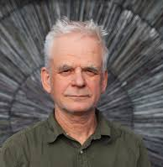  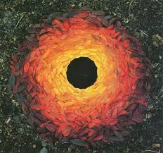  Media: Natural materials |  |  | Showcase: Flowers  Artist: Georgia O’Keefe  Media: Poster paint  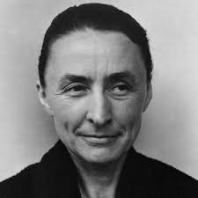  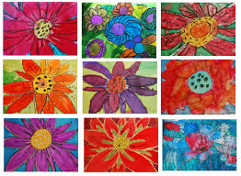
The Arts | DT |  | Discipline: Mechanisms  Product: Moving Picture (slider)  User: Me  Purpose: To illustrate a story in a performance  Designer: David Hawcock |  | Discipline: Structures  Product: Bridge  User: Billy Goats Gruff  Purpose: To cross a river  Architect: James Brindley  ` |  |  |   Discipline: Cooking & Nutrition  Product: Smoothie  User: Children in Reception and Nursery  Purpose: To drink and help us be healthy  Designer: Richard Reed (Innocent Drinks)
The Arts | Music | Hey You!  Rhythm in the way we walk |  | In the groove  Round and round |  |  | Your imagination  Reflect, rewind and replay
Wider curriculum | Trips and workshops | - European day of languages  - Composting Warwickshire Worship  - Fire service visit |  | Plastic Free Warwickshire Worship |  |  | Food Waste Warwrickshire Worship
Wider curriculum | Christian Ethos | - Messy Harvest  - Messy Christmas |  | - Messy Easter |  |  | - Pentecost

