


WOODSIDE C.E.(VC) PRIMARY SCHOOL

Opal Play Policy
2025-2026

Date Ratified: | September 2025
Date Due for Review: | September 2026
Signed Head Teacher:
Signed Chair of LAB (where appropriate):
.

Commitment
Our school undertakes to refer to this play policy in all decisions that affect children’s play. Our school is committed to providing the strategic and operational leadership needed to provide and maintain quality play provision for all our children.

Rationale
Our school believes that all children need opportunities to play that allow them to explore, manipulate, experience and affect their environment. The school acknowledges the UN Convention on the Rights of the Child, especially Article 31, and supports the child’s right to play. We believe play provision should be welcoming and accessible to every child, irrespective of gender, sexual orientation, economic or social circumstances, ethnic or cultural background or origin, or individual abilities.

The OPAL programme rationale is that “… better, more active and creative playtimes can mean happier and healthier children, and having happier, healthier, more active children usually results in a more positive attitude to learning in school, with more effective classroom lessons, less staff time spent resolving unnecessary behavioural problems, fewer playtime accidents, happier staff and a healthier attitude to life.”
The principles of OPAL align with our school value of love, hope, challenging injustice, forgiveness as well as respect. We encourage and support the children as they engage in play as a way of demonstrating Christian Values towards each other. We believe in nourishing the children as individuals and helping them flourish and grow. The approach provided through the OPAL project will further enhance provision during playtime and provides another means of promoting the British Values in a child friendly way. Play allows the children to express their knowledge of British Values, such as democracy, in an informal environment.

Definition and value of play
Play is defined as any freely chosen activity that a child finds satisfying and creative. It may or may not involve equipment or other people. We believe play has many benefits, including:

  - Play is critical to children’s health and wellbeing, and essential for their physical, emotional,
social, spiritual and intellectual development.
  - Play enables children to explore the physical and social environment, different concepts and different ideas.
  - Play enhances children’s self-esteem and their understanding of others through freely chosen social interactions, within peer groups, with individuals, and within groups of different ages, abilities, interests, genders, ethnicities and cultures.
  - Play requires ongoing communication and negotiation skills, enabling children to develop a balance between their right to act freely and their responsibilities to others.
  - Play enables children to experience a wide range of emotions and develop their ability to cope with these, including sadness and happiness, rejection and acceptance, frustration and achievement, boredom and fascination, fear and confidence.
  - Play encourages self-confidence and the ability to make choices, problem solve and to be creative.
  - Play maintains children’s openness to learning, develops their capabilities and allows them to
push the boundaries of what they can achieve

Aims
In relation to play our school aims to:

  - ensure play settings provide a varied, challenging and stimulating environment for the children's enjoyment.
  - allow children to take risks and use a common-sense approach to the management of these risks and their benefits.
  - provide opportunities for children to develop their relationships with each other.
  - enable children to develop respect for their surroundings and each other.
  - aid children’s physical, emotional, social, spiritual and intellectual development.
  - provide a range of environments that will encourage children to explore and play imaginatively.
  - provide a range of environments which will support children’s learning across the curriculum
and learning about the world around them.
  - promote independence and teamwork within children in line with our Christian Values.
  - build emotional and physical resilience.
  - to develop children's own strategies for learning and improving.

Staff at Woodside Primary School have, through discussion, identified the anticipated outcomes of good quality play and seek to achieve this through the provision and management of playtimes. The anticipated outcomes include the children being adventurous, happy, engaged, able to expressive themselves in a variety of ways, exhilarating, challenging, physically worn out and mentally refreshed.
The effectiveness of playtimes can be measured by the children returning to learning in the afternoon with a good attitude, ready to learn with a minimal number of friendship disagreements to resolve. Children will talk very positively about playtimes, describing a range of things they enjoy doing. The number of serious accidents during playtimes should be low.

Rights
Our school recognises the UN Convention on the Rights of the Child, which includes the right to play, recreation and leisure (Article 31) and the right of children to be listened to on matters important to them (Article 12). We acknowledge that we have a duty to take these rights seriously and listen to children’s views on their play.
Our school values children's rights to a friendly and happy environment with all members of the school community showing respect to each other.
“Every child has the right to grow up in a healthy environment - to live, learn and play in healthy
places.” - World Health Organisation, 2003.

Benefit and Risk
‘Play is great for children’s wellbeing and development. When planning and providing play opportunities, the goal is not to eliminate risk, but to weigh up the risks and benefits. No child will learn about risk if they are wrapped in cotton wool.’
Managing Risk in Play Provision: An Implementation Guide (2012)

The school will use the Health and Safety Executive guidance document ‘Children’s Play and Leisure – Promoting a Balanced Approach’ (September 2012) as the principal value statement informing its approach to managing risk in play. In doing so, the school will adopt a risk-benefit approach as detailed in ‘Managing Risk in Play Provision’: An Implementation Guide.

Risk-taking is an essential feature of play provision, and of all environments in which children legitimately spend time at play. Play provision aims to offer children the chance to encounter acceptable risks as part of a stimulating, challenging and managed play environment.
In the words of the play sector publication ‘Best Play’, play provision should aim to ‘manage the balance between the need to offer risk and the need to keep children and young people safe from harm’.

In addition to standard risk-benefit assessments the school will practice dynamic risk management with children, encouraging them to identify and manage risks in an environment where adults are present to support them.

In order to prepare children for their future lives, they should have a developing ability to assess the risks and benefits of all the opportunities that present themselves to them.
We promote reflection and challenge through exploration and questioning during playtimes and lessons. We encourage children to make their own risk and benefit assessments and develop a sense of responsibility in terms of making sensible choices and giving consent, or not, to the way in which they interact with other children.

This idea of giving consent is discussed in play assemblies and also when required during playtimes. Leading on from this, children will have a growing understanding of the appropriate boundaries in healthy relationships and where consent has not been given, are more likely to feel confident to take action if needed.
This is preparing children to safeguard themselves for their future lives.

Please see Appendix 1 for statement from Health and Safety Executive regarding play in schools.

Supervision
The law requires that children in school have supervision but for primary school playtimes there are no stated ratios. During the school day there should be one or more adults present outdoors.
The school recognises OPAL’s three models of supervision: Direct, Remote and Ranging. Except for new children in reception, the school does not believe direct supervision is possible or beneficial.

Supervision will take remote and ranging models, so that children can quickly find an adult, and adults can patrol large sites to gain an awareness of the kinds of play and levels of risk likely to be emerging.

Staff are to supervise playtimes in accordance with the rota issued. Staff are to circulate their zoned area and to call upon the member of staff ‘floating’ or the play coordinator for any emergencies including first aid that cannot be dealt with outside.

The minimum requirements are: 1 staff member on the Key Stage 1 playground, 2 staff members on the Key Stage 2 playground, 2 staff members on the field and 1 staff member ‘floating’.

Staff should not send children out to play without first checking if there is a member of staff present in the area the children are playing on.

The play coordinator or Play Lead will communicate any day to day changes including the flag system which relates to the use of the field.

The adult’s role in play
The school will help children maximise the benefits they can gain from play by the provision of trained staff who are informed by and work in accordance with the Playwork Principles. Staff will use and refer to these principles when appropriate interventions are needed, and ultimately will strive for facilitating an environment that nurtures children’s self-directed play.

The playworker's core function is to create an environment that will stimulate children's play and maximise their opportunities for a wide range of play experiences. A skilled and experienced
playworker is capable of enriching the child’s play experience both in terms of the design and resources of the physical environment and in terms of the attitudes and culture fostered within the play setting. Playworkers are a channel of access to new materials and tools and they can act as a stimulus to children to explore and learn. They are also available to participate in the play if invited.

Please see Appendix 2 for the principles of playworkers

The play coordinator will meet regularly with the Play Lead to discuss future development ideas and any matters arising from other staff or the children. The play coordinator and Play Lead will plan any resources needed, introduce them to the children during play assemblies and monitor their use at playtimes. They will keep staff updated via weekly staff meetings, the staffroom notice board or emails.

Equality and diversity
Through providing a rich play offering meeting every child’s needs we will ensure all children, regardless of age, gender, race, disability or other special needs, can develop and thrive, build strong relationships and enjoy school.

Our school's Christian ethos promotes the British Values as an intrinsic part of our culture, this includes ‘mutual respect’ and ‘tolerance for those of different faiths and beliefs and none’. Children and adults treat all with courtesy, respect, integrity and dignity as detailed in our “Equality and
Diversity Policy and Single Equality Scheme.”

Environment

We believe that a rich play setting should ensure that all children have access to stimulating environments that are free from unacceptable or unnecessary risks and thereby offer children the opportunity to explore for themselves through their freely chosen play.

We will strive to continually improve the quality and diversity of our school’s grounds to enhance play. We will use the document ‘Best Play’ to guide us on what a quality play environment should contain.
http://www.playengland.org.uk/resource/best-play/

Appendix 1
HSE Guidance - Promoting a balanced approach
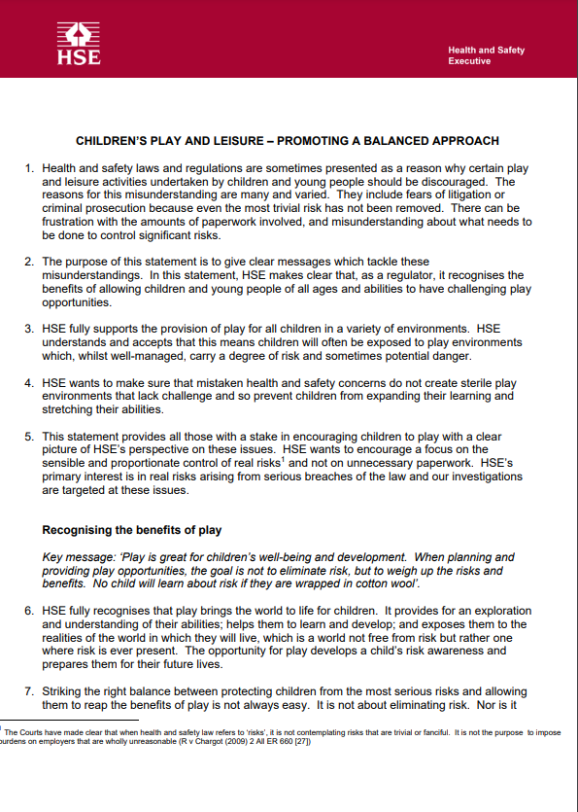

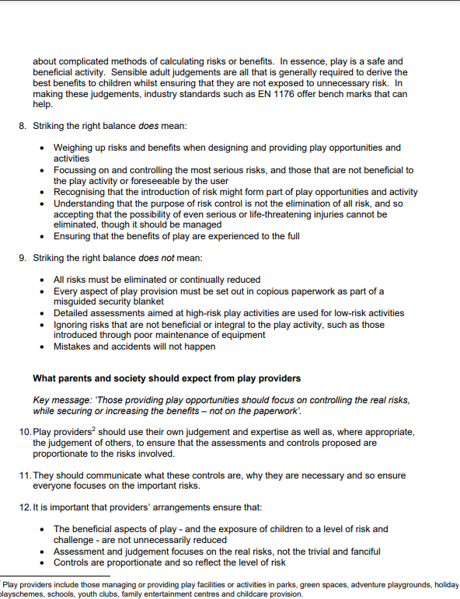

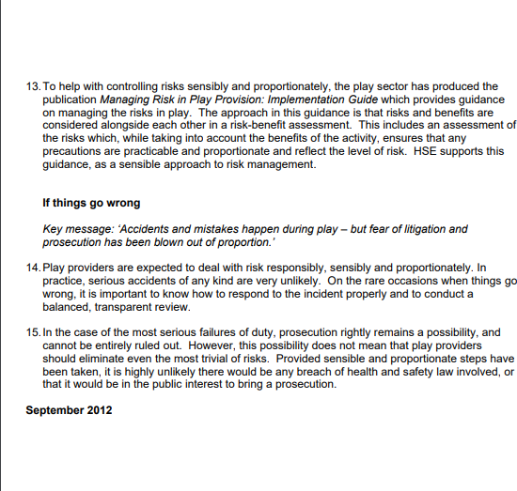

Appendix 2
Playwork principles
